TIME COMPLEXITY AND SPACE COMPLEXITY

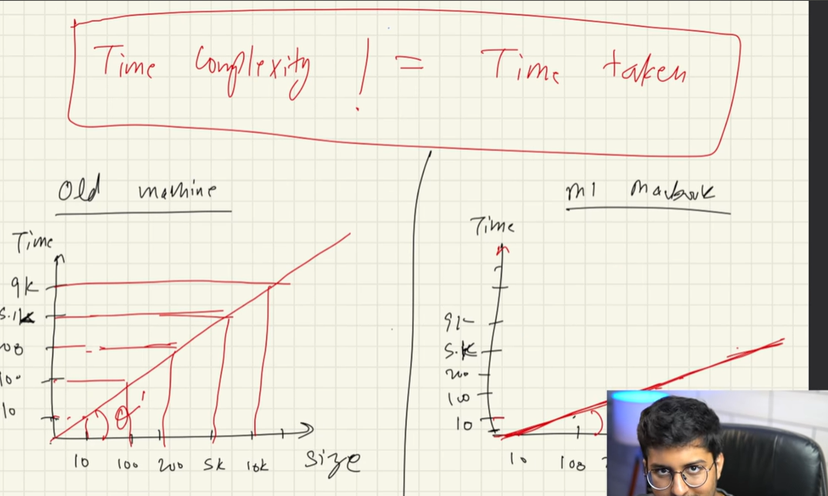

Linear vs Binary Search



